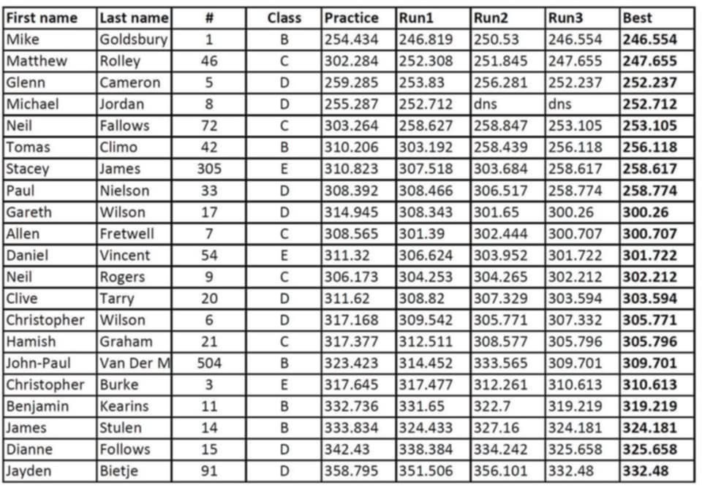

Note: Times above should be read as first digits/numbers are minutes, remaining digits/numbers are seconds and decimals.

Provisional points for SCCNZ members taking part:

Hamish Graham 89.6

Ben Kearin 83.6